-Assignment: Creating a Database Using MongoDB **and Mongosh**

**MongoDB:** MongoDB is a source-available, cross-platform, document-oriented database program. Classified as a NoSQL database product, MongoDB utilizes JSON-like documents with optional schemas. MongoDB is developed by MongoDB Inc.

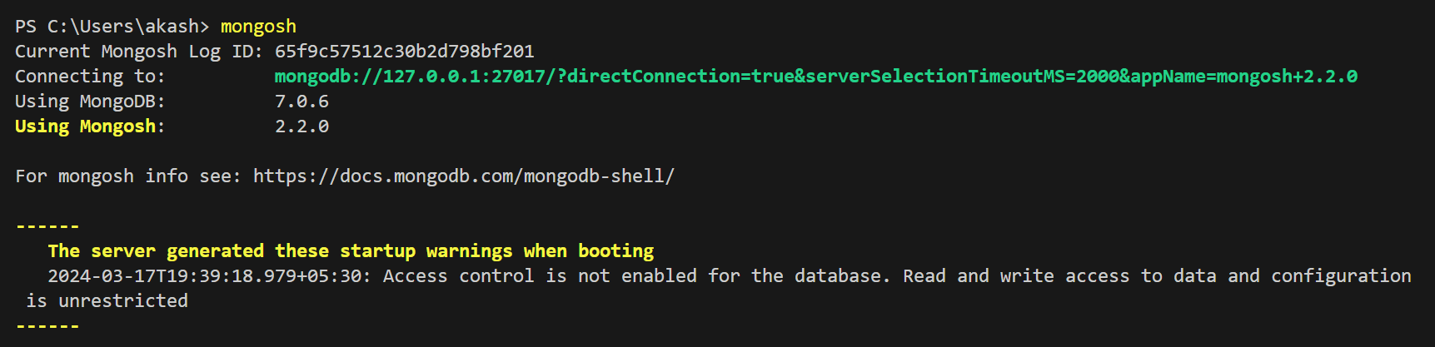

# **Assignment Details:**

* **Database Setup**: Created a new MongoDB database called “School”.
* **Collection Creation**: Created a collection named Student within the school database.

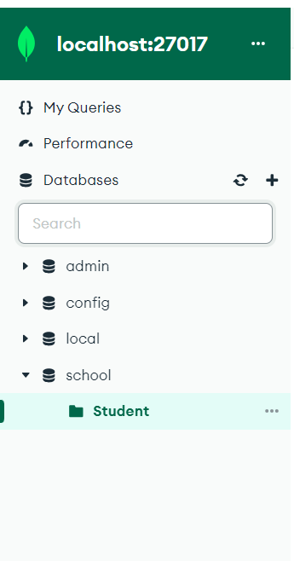

* **Document Insertion**: Inserted three documents into the Student collection, each representing a Student with fields such as name, age, and height.

**In MongoDB PowerShell:**

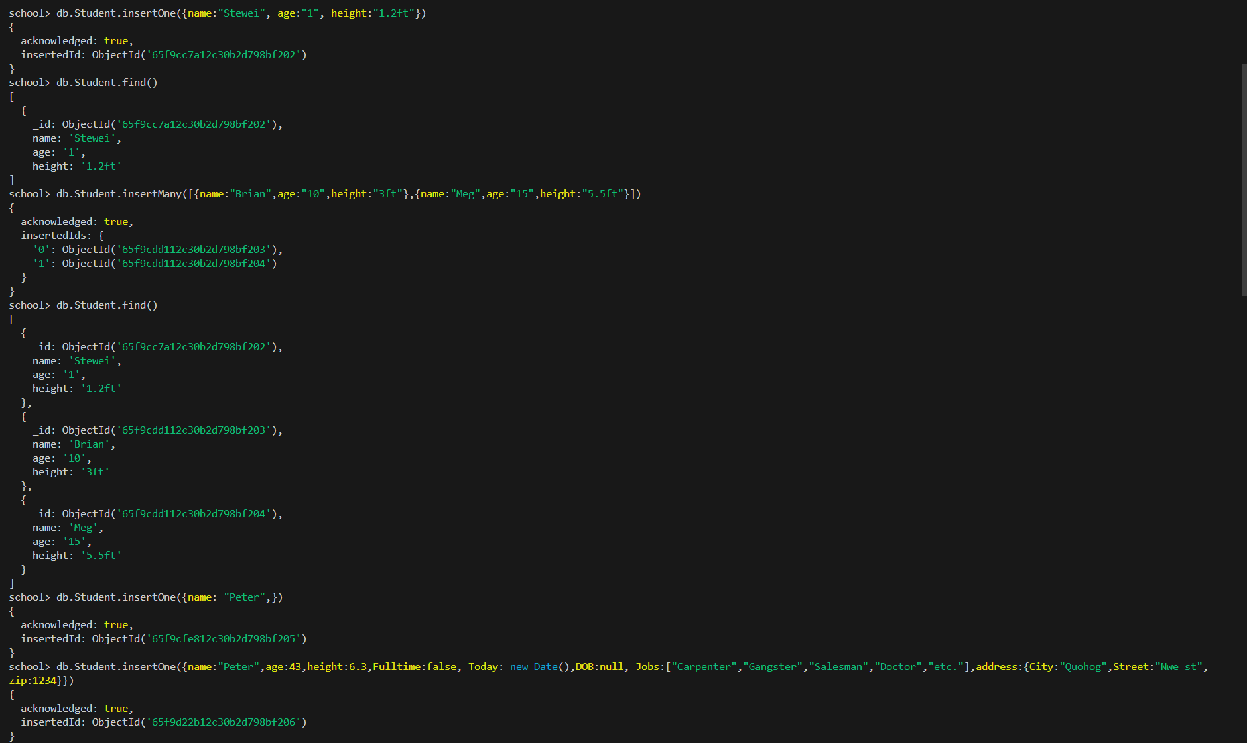

**In Compass:**

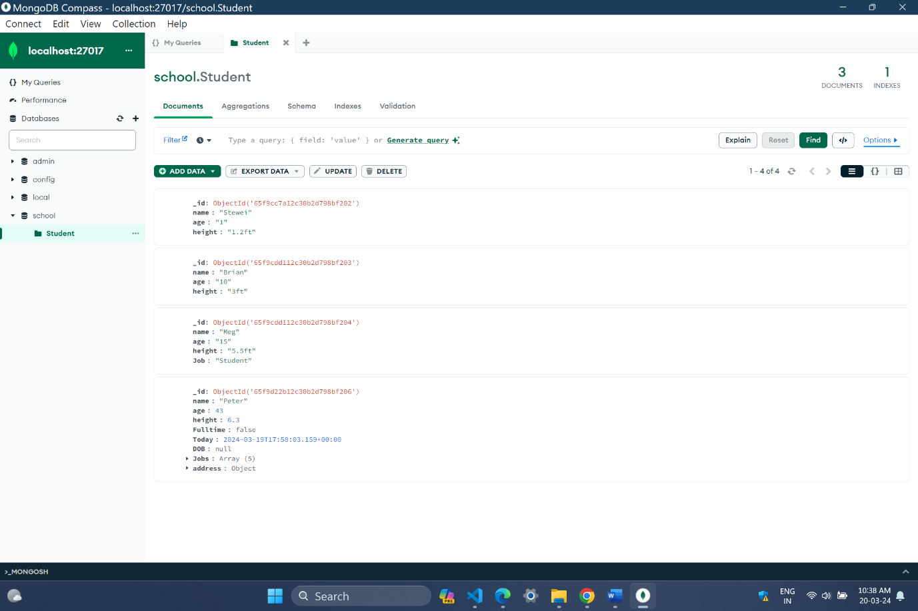

* **Querying:** queries to retrieve: All students from the Student collection. Student with an age greater than or equal to 30.

*Comparison Operator*: operators return data based on value comparisons

Less than: ($lt)

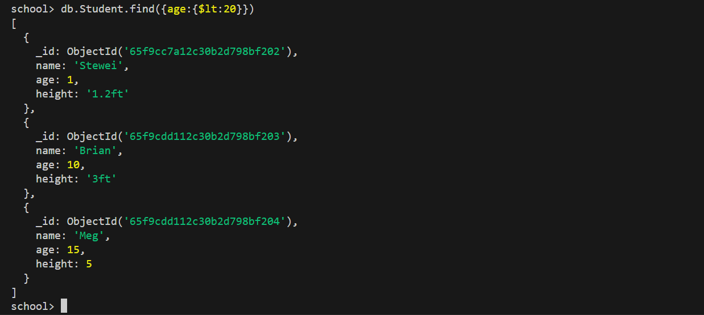

Greater than: ($gt)

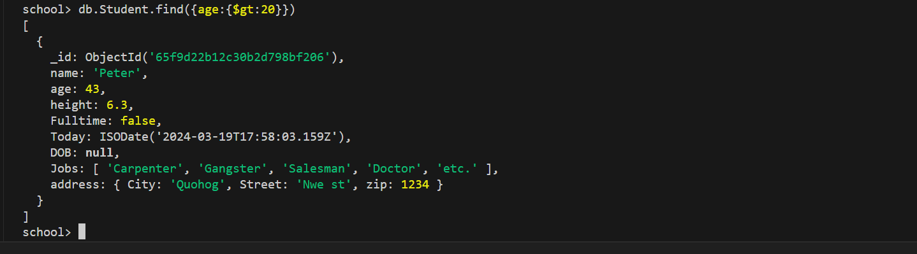

Less than equal ($lte)

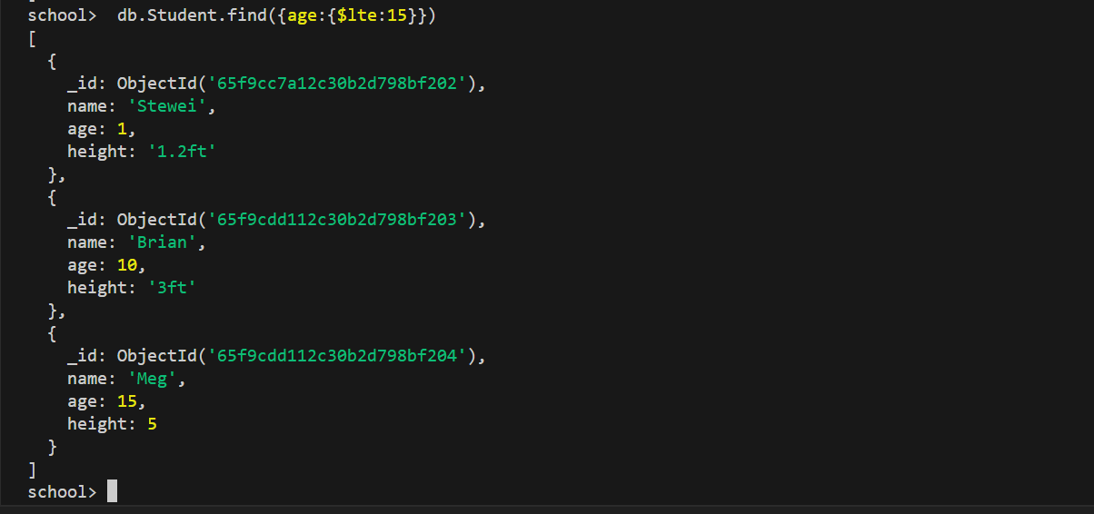

* **Update Operation:** Updated the Job of a student with a specific name.

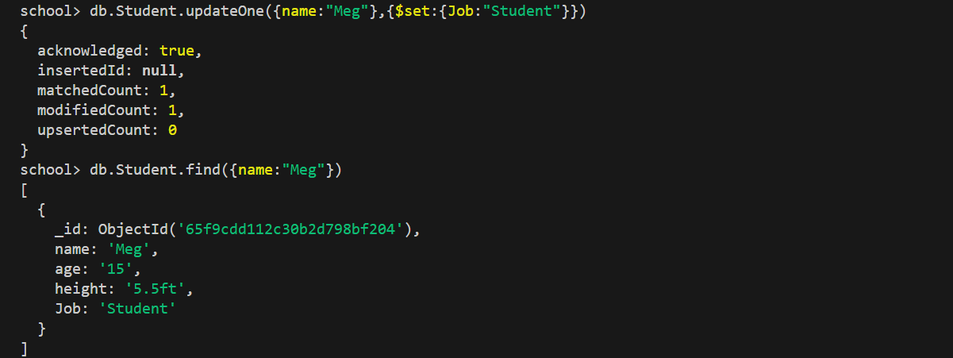

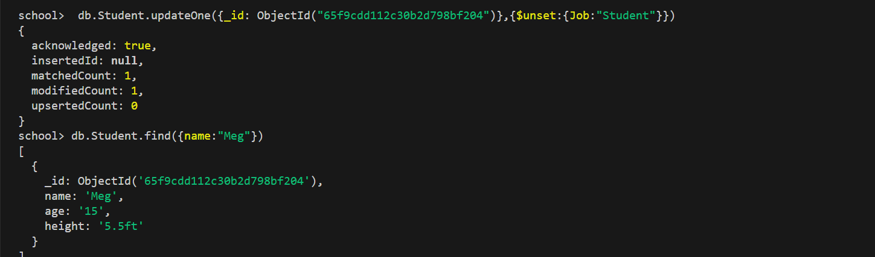

By default, the [db.collection.update()](https://www.mongodb.com/docs/manual/reference/method/db.collection.update/" \l "mongodb-method-db.collection.update" \t "_self) method updates a **single** document. Include the option [multi: true](https://www.mongodb.com/docs/manual/reference/method/db.collection.update/#std-label-multi-parameter) to update all documents that match the query criteria.

* **Deletion Operation:**

The MongoDB shell provides the following methods to delete documents from a collection:

* To delete multiple documents, use [db.collection.deleteMany().](https://www.mongodb.com/docs/manual/reference/method/db.collection.deleteMany/" \l "mongodb-method-db.collection.deleteMany" \t "_self)
* To delete a single document, use [db.collection.deleteOne().](https://www.mongodb.com/docs/manual/reference/method/db.collection.deleteOne/" \l "mongodb-method-db.collection.deleteOne" \t "_self)
* Delete a user document based on a specific name.



In compass:

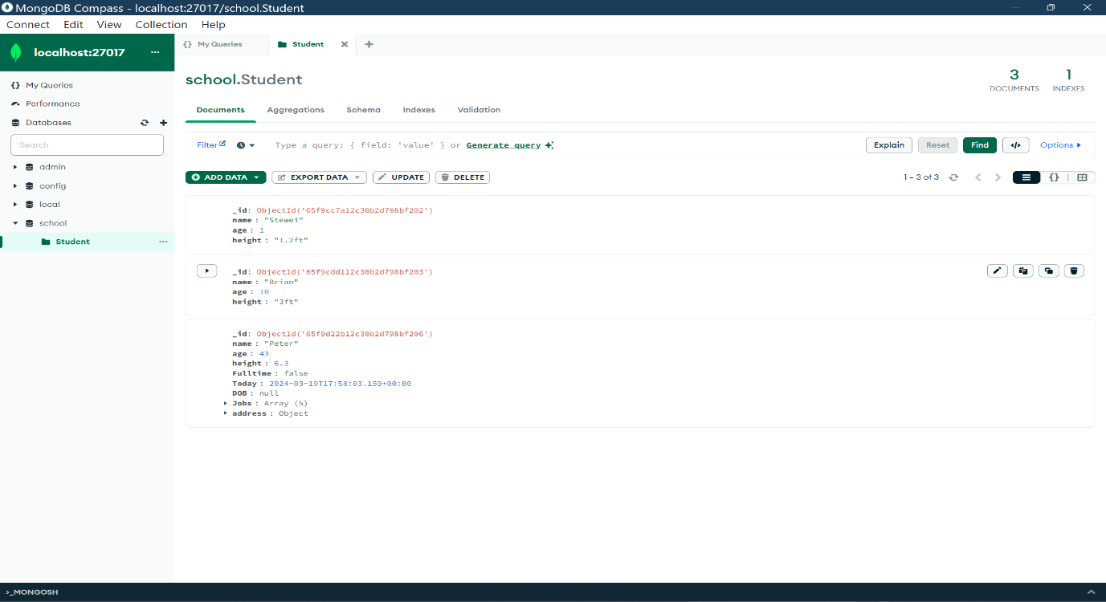

* **Index Creation:**

Indexes support efficient execution of queries in MongoDB. Without indexes, MongoDB must scan every document in a collection to return query results. If an appropriate index exists for a query, MongoDB uses the index to limit the number of documents it must scan.

